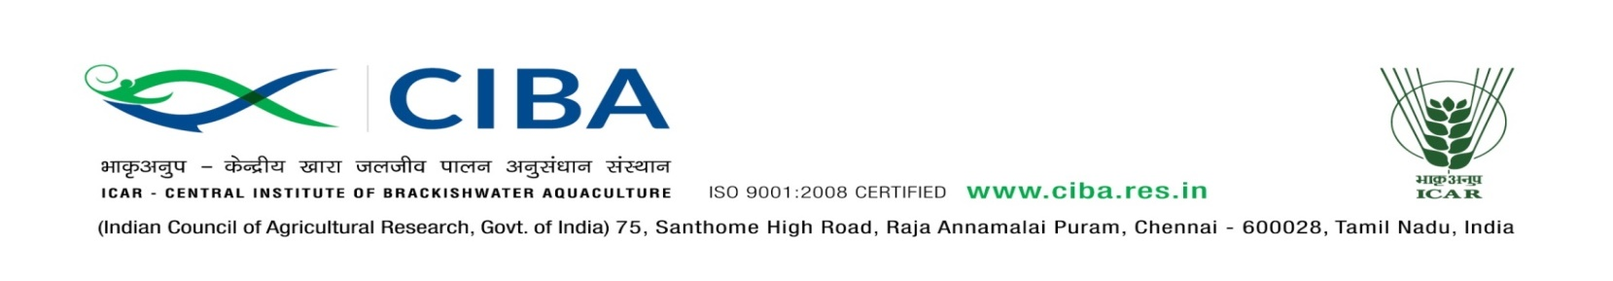
Applications are invited to attend Interview (in-person/ online through video conferencing) for the position of “Young Professional II” on purely temporary basis as per the details given below

Post | Young Professional II – 4 Nos.
Date of submission of Bio-data | 30th June, 2020
Date & Time of Interview | Will be intimated to shortlisted candidates
Project Name | National Innovations in Climate Resilient Agriculture (NICRA)
Duration | Till March 2025 or termination of the project whichever is earlier
Essential  Qualification | - M.F.Sc  - M.Sc (Ag) in Soil Science  - Master’s degree in the Basic sciences with specialization in Chemistry, Agricultural Chemistry, Biochemistry, Aquaculture, Microbiology, Marine biology, Environmental Sciences, Climate change  - MTech / BTech / MCA/ MSc degree in computers / Information technology
Desirable | - Working knowledge in their subject as evident through dissertation/Project work/ Research Publications.  - Necessary Computer knowledge for data entry and analyzing scientific research data.  - Knowledge of computer simulation and modeling and programming skills in Python any other language  - Working experience on Life cycle analysis (LCA) software
Job Profile and place of posting | The selected candidates will be responsible for providing assistance to project activities at ICAR-CIBA, Chennai
Emoluments | Rs.25000 (Consolidated)
Age Limit | Maximum 35 years for men and 40 years for women as on date of interview. Relaxation for SC / ST / OBC candidates as per rules.

Eligible candidates may send their Curriculum Vitae (clearly indicating their experience and skills/instruments used) along with the contact numbers in the prescribed proforma (attached) and scanned copy of the original documents only through e-mail to moturimurali@gmail.com on or before 30-06-2020. The applicant should indicate “Application for YP–II NICRA” in the subject line of his/her email.

Owing to the prevailing COVID-19 crisis, candidates selected after initial screening will be informed for further details regarding interview (in-person/ online through video conferencing) by email or over phone. Director, CIBA reserves the right to accept or reject any applications. Candidates appearing for interview in-person should attend with filled in application form. Original documents of the candidates (all certificates and relevant documents) appearing interview in-person will be verified on the interview date and for the candidates appearing online interview will be verified at a later stage. CIBA does not enter into correspondence with the applicants for not calling them for interview. TA/DA will not be paid for attending the interview.

Principal Investigator
Application Form

 | Application for the post |  | Recent passport  size photograph
 | Name (in Block Letters)
 | Date of Birth (DD/MM/YY)
 | Age as on date of advertisement
 | Gender: M/F
 | Marital Status
 | Father/Husband Name
 | Category: SC/ST/OBC/General
 | Mother Tongue and languages known (Speak/Read/ Write)
 | Permanent address with Pin Code
 | Address for communication (If different)
 | Mobile No.
 | E-mail Address

- Qualifications: Details of educational qualification from 10th onwards

Examination | Subject | Name of Institution | Year of Passing | % of marks/ GPA obtained

- Working Experience (if any)

S.No. | Post/Position Held | Employer | Period (From – To) | Work done/ Experience

If currently employed, whether obtained NOC from present employer

Details of publications
Name and address of referee along with phone number and e.mail ID

DECLARATION

I hereby declare that I have carefully read and understood the instructions and particulars on this application and that all entries in this form are true to the best of my knowledge and belief. If any information is found false, my candidature and services if selected may be terminated without any notice.

Signature
Date:

Place:

